SecureFi.AI
Risk Intelligence for What You Depend On
Check-In | Watch | Recover · Platform overview, October 2026
SecureFi.AI is a risk intelligence platform that helps individuals, families, businesses and public safety organizations understand when something they depend on needs attention, what it means, and what to do next.
Rather than replacing the systems people and organizations already use, SecureFi adds an independent layer of trusted risk intelligence across the devices, equipment, services, vendors and vehicles they rely on.
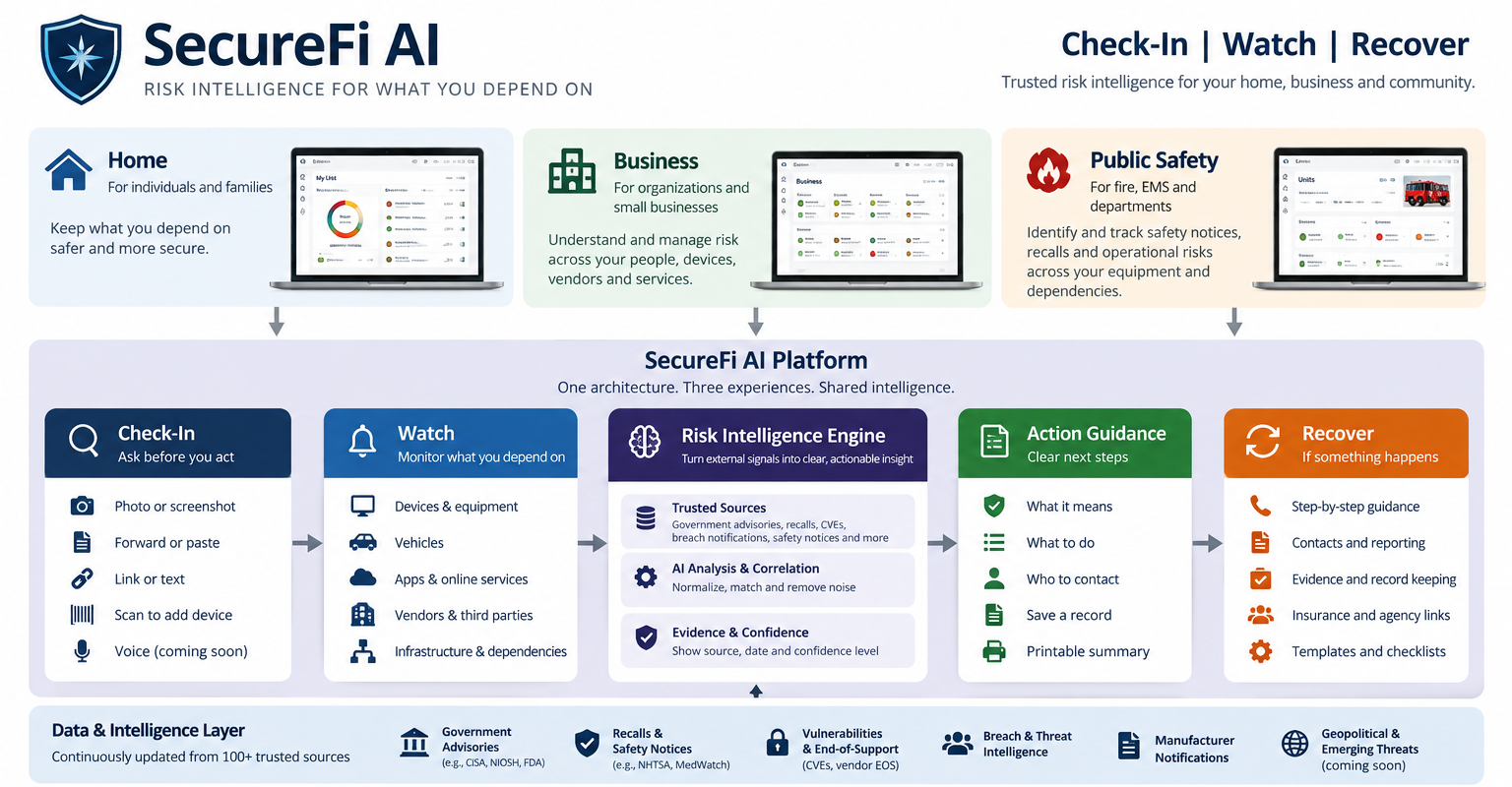
Three experiences, one platform
Home  Individuals and families | Business  Organizations and small businesses | Public Safety  Fire, EMS and other departments
- Home network and Wi-Fi equipment  - Computers, phones and tablets  - Vehicles  - Apps and online services  - Connected home products  - Financial and identity services | - Devices and equipment  - Cloud and software providers  - Vendors and third parties  - Systems holding customer or employee data  - Payments, payroll and sign-in  - Network and communications | - Stations and units  - Fire apparatus and EMS vehicles  - SCBA and life-safety equipment  - Radios and communications  - Medical and rescue equipment  - Mobile computing and network gear
Each experience sorts everything into four clear states: needs attention now, needs one answer, quiet in the sources checked, and not monitored yet.
How it works
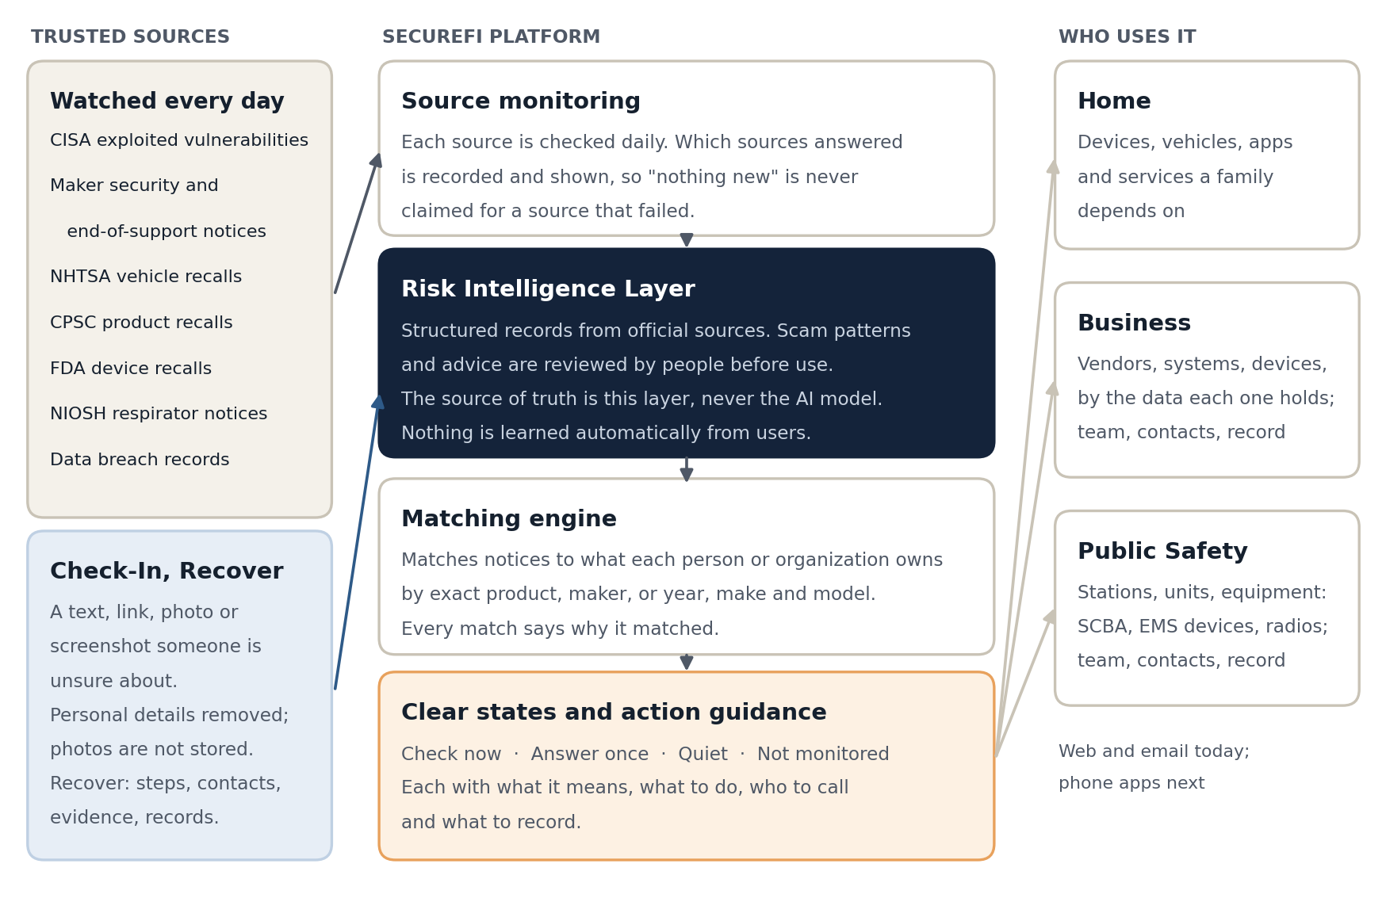
- Official sources, with people in the loop. Alerts come from government and manufacturer publications held as structured records. Scam patterns and the guidance SecureFi gives are reviewed by people before use. AI assists with reading and classification; it is never the source of truth, and nothing is learned automatically from what users send.
- Every result shows its reasoning. How it matched, which source it came from, and whether that source answered today.
- Action guidance, not just alerts. What the issue means, what to check, what to do, who to contact, and what to record. Organizations can record actions for later review.
- Privacy by default. Photos are read and discarded, sensitive numbers are minimized before anything is kept, and product identifiers are limited to what is needed for matching whenever possible.
Trusted sources
SecureFi is built on authoritative external sources rather than a single proprietary feed: government advisories, consumer, vehicle and medical device recalls, safety notices, known exploited vulnerabilities, cybersecurity advisories, breach information, manufacturer notices and end-of-support information. Source organizations include CISA, FDA, NHTSA, CPSC, NIOSH, state agencies and manufacturers, more than 100 sources across the platform.
What is running today
Capability | What it does | Status
Check-In | Text, links, emails, pictures and screenshots checked before someone acts, with AI-assisted guidance. | Running
Watch | Personal, business and department lists monitored daily: devices, vehicles, apps, vendors and equipment. | Running
Recall, notice and vulnerability matching | Recalls, safety notices, exploited vulnerabilities and maker notices matched to what each list holds, with the reason for every match. | Running
Answer-once questions | When one fact settles a notice (a fitting, a version, a lot code), SecureFi asks once and applies the answer to future notices. | Running
Breach information and active alerts | Breach records and urgent alerts by email, with a morning brief for teams. | Running
Source verification and health | Every result shows its source; each morning shows which sources answered. | Running
Threat Intelligence | Who has been caught, a scam library, and search. | Running
Recover and Evidence Pack | Step-by-step recovery, reporting support, evidence preservation and printable summaries. | Running
Business | Vendor and dependency monitoring organized by the data each one holds; team access; action tracking; monitoring record; printable who-to-call sheet. | Running
Public Safety | Stations, units and equipment monitoring for fire and EMS. | Running
Scan-to-add | Photograph a product label to add it to Watch; the photo is read and discarded. | Running
Version and end-of-support tracking | Software and firmware versions and support dates for devices and equipment. | Running
Easier onboarding | Inventory and CSV import, organization roles and setup. | Running
iPhone and Android apps | The same service as native apps. | Running
How SecureFi fits with existing systems
SecureFi is not meant to replace inventory, fleet, dispatch, patient-care reporting or asset management systems. It answers a different set of questions, which makes it complementary to them.
Existing systems answer | SecureFi answers
What do we own?  Where is it, and who has it?  Was it inspected?  When is maintenance due?  Is it in service? | Has something changed about what we depend on?  Has it been recalled, or is there a new safety notice?  Is it vulnerable, or has support ended?  Has a vendor been breached?  Is this warning authentic, and what do we do next?
How the platform addresses common market questions
Question | How SecureFi addresses it
Ease of use for older adults | Watch asks for nothing day to day: things are added once and SecureFi does the watching. Scan-to-add removes typing, and Check-In accepts a photo or screenshot instead of copy and paste. Testing with older users on their own phones, at large text sizes, is the next step.
Overlap with email spam filters | SecureFi does not compete on inbox filtering. The core is the things people and organizations depend on, which an inbox provider cannot see.
Consumer security suites | SecureFi does not offer stolen-funds reimbursement and does not try to; suites that do solve a different problem. SecureFi answers its own question: does a published problem affect something you depend on, and what do you do about it. Business and Public Safety have no consumer-suite equivalent.
Tagline and feature groups | Check-In, Watch and Recover, under "Risk intelligence for what you depend on." The same three words are the product’s own navigation.
Scope | SecureFi does not claim to cover every stage of fraud. It states what it covers and what it does not.
Defining the market | SecureFi defines its category as risk intelligence for what people and organizations depend on: complementary to spam filters, security suites and asset systems, not a replacement for any of them.
Security alerts for home devices | Watch already monitors supported devices, apps and vehicles against applicable trusted sources, including CISA’s exploited-vulnerability catalog and selected manufacturer security and support notices. Scan-to-add and version tracking extend it.
What SecureFi does not do
- It does not reimburse stolen funds or act as identity-theft insurance.
- Not every connected device has published security advisories; many household gadgets rarely do. Where no source covers an item, SecureFi says "not monitored" rather than implying it is safe.
- A notice that names a model but not a specific version or serial range needs one answer from the owner to settle; SecureFi asks rather than guesses.
- Vehicle and product recall sources are U.S. agencies today; vulnerability data is global.
The goal throughout: help people and organizations understand what changed, why it matters, what can be trusted, and what to do next.

